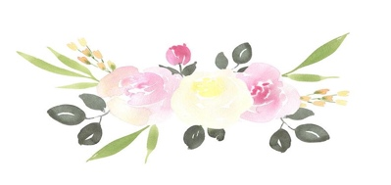
Heidi’s Dance Academy - Class Description
Creative Movement
This is a fun and imaginative introductory class to dance. We will explore movement, rhythm, imagery and sing along songs to encourage timing, balance, counting and control. This is a 30 minutes class.
What to wear: Any leotard, tights and pink ballet shoes. (skirt is optional) Hair should be neatly pulled back away from face.

Combo Class
This class is an excellent beginner class for all dancers to get their feet wet into 3 different genres of dance (ballet, tap, & jazz). We will introduce foundation steps of ballet, tap and jazz as we enjoy learning to stretch, correct posture and creating a story and mood through movement.
What to wear: Any leotard, tights and pink ballet shoes and black tap shoes. (skirt is optional) Hair should be neatly pulled back away from face.

Level 1-4 Tap
These classes are to build technique, style and tone in the fun and creative world of rhythm tap and sound. Each level is designed to encourage growth as well as build your skills to increase your ability in tap development.
What to wear: Any leotard with leggings or tights. Black tap shoes. Hair should be neatly pulled back away from face.

Level 1-4 Jazz
These classes will use tradition jazz technique to develop each students movement in a variety of styles and levels of dance. We will explore classic and new found favorites as well as create ways to shape movement to create a picture. Strength, endurance, groove, and funky fun will be included. What to wear: Any leotard with leggings or tights. Black jazz shoes. Hair should be neatly pulled back away from face.

Level 1-4 Ballet
These classes will be based on your dance experience as well as skill. Each level will be several years of development before both vocabulary, choreography and proper technique to advance to the next level. Emphasis on body placement, proper position, as well as graceful variations in center will be taught at the barre, in center, and across the floor.
What to wear: Any leotard with leggings or tights. (skirt is optional) Pink ballet shoes & pointe shoes should be approved by the teacher. Hair should be neatly put into a bun.

PBT
Progressing Ballet Technique (PBT) is an innovative body-conditioning and strengthening program that has been designed to enhance students’ technique by focusing on training the muscle memory required in each exercise in all forms of dance. PBT focuses on core strength, weight placement and alignment of the body with a gradual approach of carefully designed exercises and repetitions of these exercises that trigger their muscle memory.

